**Question 1: How does the number of inspections change over time (use month as the level of temporal granularity)? Does the number of inspections increase or decrease over time?**

In general, there is a trend for the number of inspections to increase over time, especially since 2018, when there was a considerable increase in the inspection number.

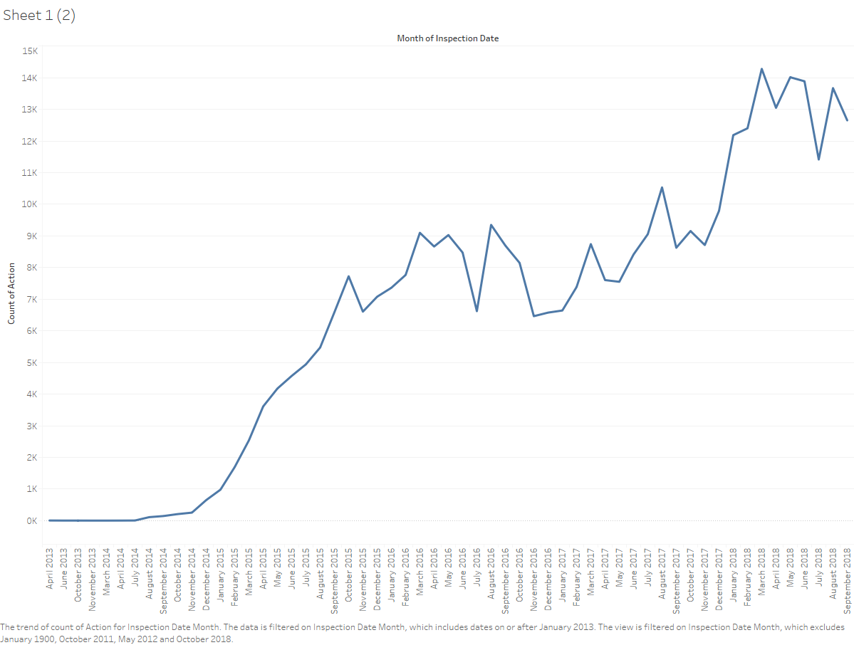

**Are there any peak times? Is there any seasonal efect (like inspections being more common during cretain seasons or months)?**

Analyzing the cyclic trend (seasonal effect) of the inspections, it can be seen that August is the month with more inspections (39 138 in total) followed by September (36 706) which can depict a seasonal effect at the end of summer.

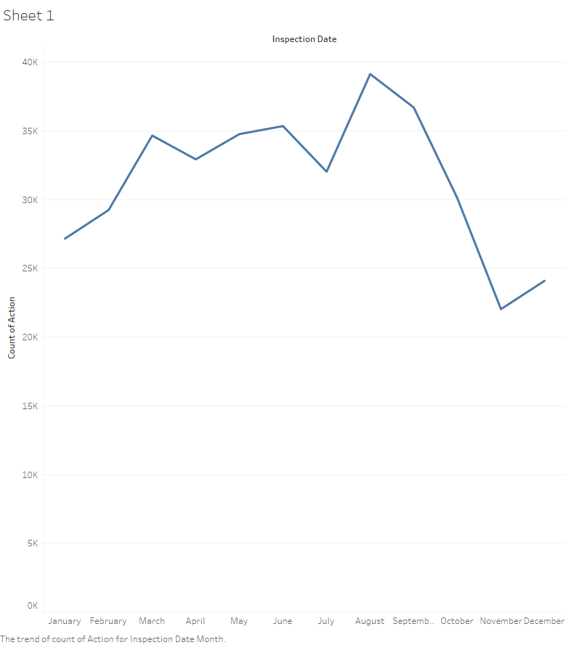

**Question 2: Is there any difference in how the number of inspections changes over time in the 5 different boroughs of New York City?**

Apart from *Staten Island* and maybe *Bronx*, it seems that the inspections preserve the same increasing trend over time in all of the boroughs.

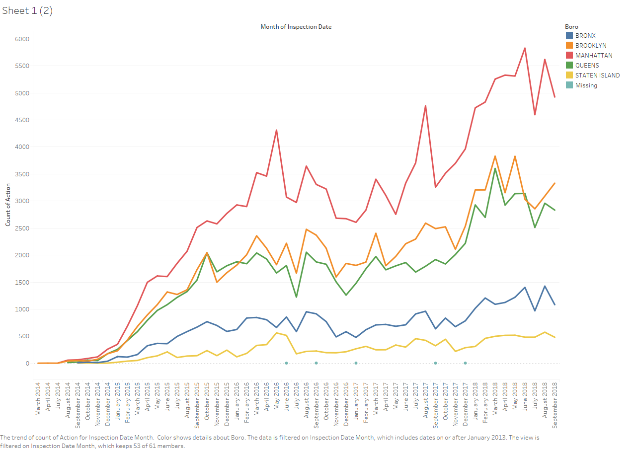

**Question 3: How are cuisines types distributed across the New York area? Are there geographical areas where certain cuisines tend to concentrate (that is are there any areas where certain cuisines are more prevalent than others)? NOTE: focus only on the top 5 most frequent “Cuisine Description” categories.**

The choropleth map, shows the distribution of the number of restaurants across the boroughs while the pie chart illustrates the distribution of the top 5 cuisine types.

In general, American cuisine is the most popular category in all of the boroughs, followed by Chinese and Latin cuisine.

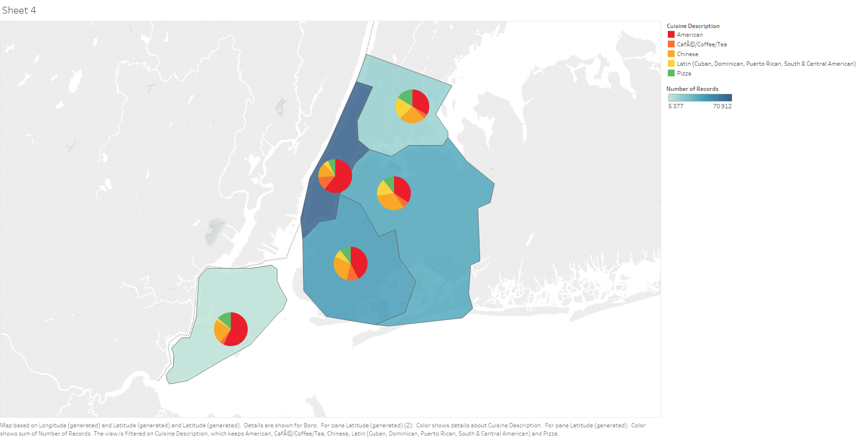

**Question 4: How does the average score compare across di?erent cuisine types? Are there cuisines that tend to have consistently lower/higher average scores compared to the others? NOTE: focus only on the top 5 most frequent “Cuisine Description” categories.**

The average score across the different cuisine types is pretty consistent and similar, however it seems that Latin and Chinese cuisines have the top scores ~21 while American and Pizza have an average near 18-19 while the worst average score is for Coffees with 17.

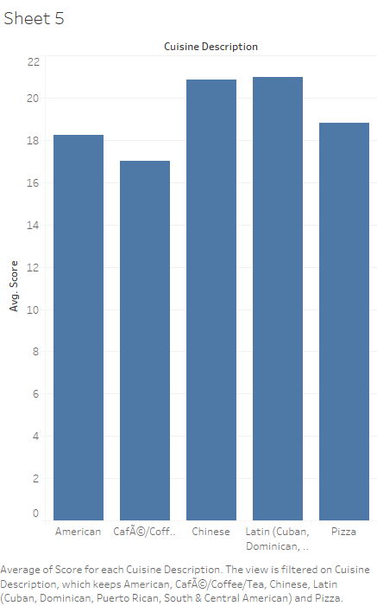

**Question 5: Is there a relationship between cuisine type and violation? For instance, do some cuisine types tend to have more of some type of violations that other cuisine types?**

After the exploratory analysis using the matrix of violation type vs. cuisine type, it seems that some of the most common violations are committed in all restaurant types and there is no clear relationship between the two attributes, at least in exploring the top 20 violation types.

